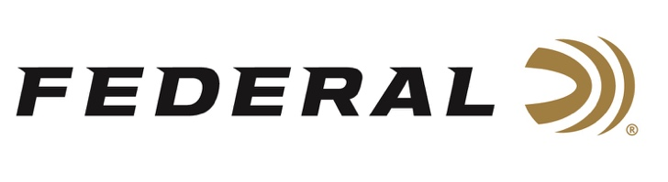

FOR IMMEDIATE RELEASE

Hopes and Expectations are High for USA Shooting Shotgun Teams

ANOKA, Minnesota – June 23, 2021 – As the opening ceremony of the 2021 Olympics draws closer, the athletes’ excitement and anticipation are growing. The USA Shooting shotgun teams are training hard, and its members are carefully considering what they expect of themselves, and what they want for the team competing in Japan this year.

“Federal Ammunition sponsors the highest level of competition shooters, and we could not be happier to watch the USA Shooting Team compete on the world stage,” stated Jason Vanderbrink, President of Federal Ammunition. “We know they will proudly represent our country and it’s an honor to be part of their journey to the medal stand.”

“I couldn’t be happier to be competing in the Olympics for the fourth time in my career,” said two-time gold medal winner Vincent Hancock. “I and the rest of Team USA are set up for success in Tokyo. Though we are individual competitors, this is the closest knit team I’ve ever been on and I'm excited. I’m ready to do my best and the team’s ready to do its best and bring home as many medals as possible!”

“I expect myself and my teammates to represent our country with honor and dignity,” said trap shooter Derrick Mein, who recently won the Super Sporting even at NSCA’s U.S. Open last weekend at Claythorne Lodge in Kansas. “We will ensure the world sees the best of the USA in both victory and defeat.”

"I expect to have a lot of fun,” said Kayle Browning, another first-time competitor. “Less than 1 percent of people can call themselves Olympians and that makes competing in the games a pretty unique experience. I intend to enjoy it and take in all the moments I can, because we all have put in a lot of hard work to get here!"

“The team and I will put up the highest scores we possibly can,” said Austen Smith, yet another first-time Olympian. “We’ve been training hard for these past few years and everything we’ve accomplished has led us to this exciting moment.”

“I expect to represent my country well, I expect to be focused, and I expect to win,” said Brian Burrows, who remembers seeing his first Olympic Games in 2004 and making it his mission to compete there. “As a team I feel that we are very strong. We are both mentally tough and very experienced competitors. Even though shooting is mostly an individual sport, we will work together as Team USA to support and encourage one another. I expect to see great things from us in Tokyo.”

Federal is the official shotshell ammunition sponsor and supplier of USA Shooting, a non-profit organization that promotes the shooting sports and prepares American athletes to bring home Olympic gold. Learn more at: www.usashooting.org.

Federal Ammunition can be found at dealers nationwide or purchased online direct from Federal. For more information on all products from Federal or to shop online, visit www.federalpremium.com.

Press Release Contact: JJ Reich
Senior Manager – Press Relations
E-mail: VistaPressroom@VistaOutdoor.com

About Federal Ammunition
Federal, headquartered in Anoka, MN, is a brand of Vista Outdoor Inc., an outdoor sports and recreation company. From humble beginnings nestled among the lakes and woods of Minnesota, Federal Ammunition has evolved into one of the world's largest producers of sporting ammunition. Beginning in 1922, founding president, Charles L. Horn, paved the way for our success. Today, Federal carries on Horn's vision for quality products and service with the next generation of outdoorsmen and women. We maintain our position as experts in the science of ammunition production. Every day we manufacture products to enhance our customers' shooting experience while partnering with the conservation organizations that protect and support our outdoor heritage. We offer thousands of options in our Federal Premium and Federal® lines-it's what makes us the most complete ammunition company in the business and provides our customers with a choice no matter their pursuit.

